Assignment 1 External Documentation

John Cetin

100955200

COMP3064

Table of Contents

Detailed Game Description 3

Control Description 3

Interface Sketch 3

Screen Descriptions 4

Enemies 5

Scoring 5

Sound Index 6

Art/Multimedia Index 6

Notes 7

# Detailed Game Description

Firefight is a 2D space shooter where the player takes control of a space ship and has to avoid/destroy enemy ships coming its way. The player will be able to shoot and movie around in the game. They can collect gems which will increase the score that the player can get. The player will have health and when all health is depleted, it is game over.

# Control Description

The player can move the space ship with the arrow keys or the WASD keys. The player can shoot by pressing the “m” key.

# Interface Sketch

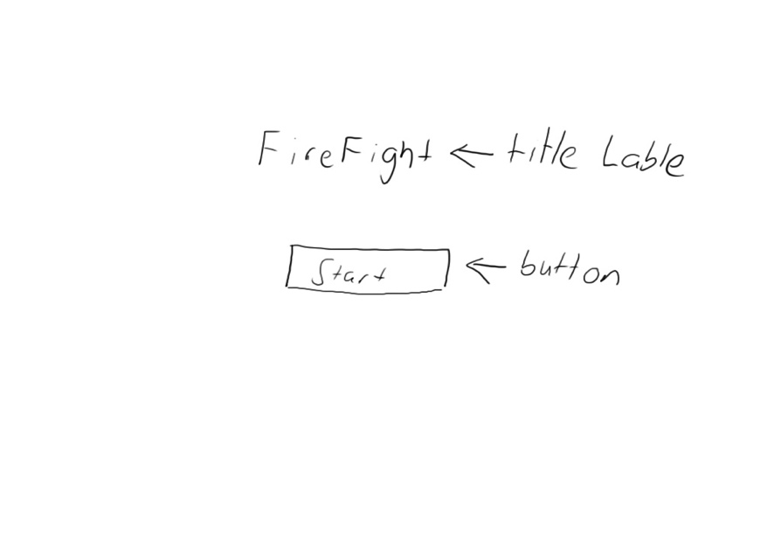

Menu sketch^

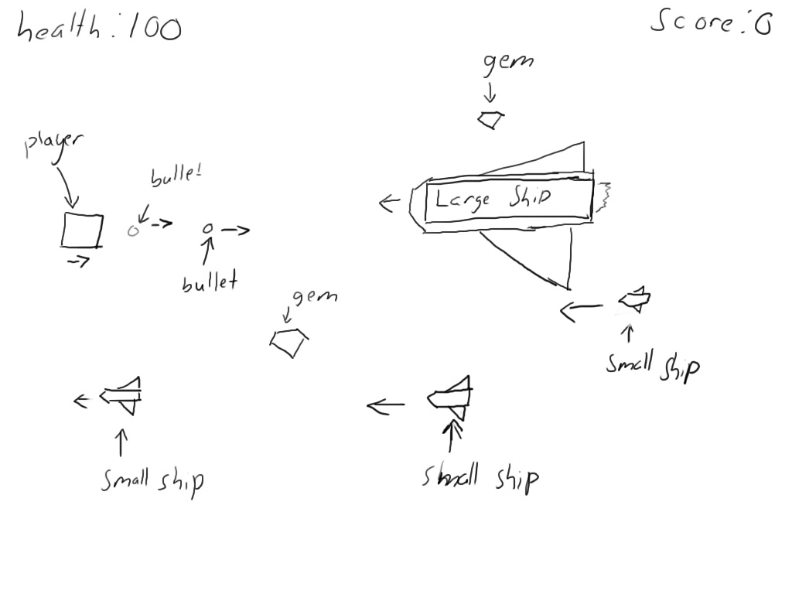

gameplay sketch^

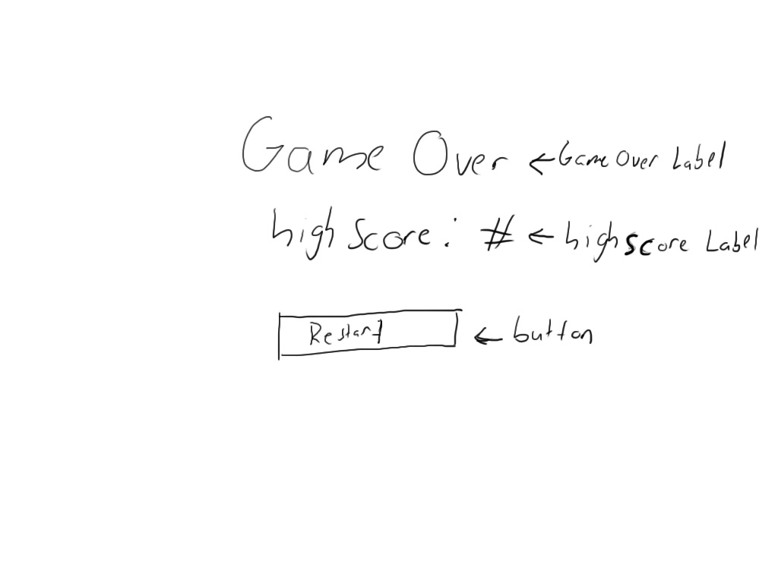

game over sketch^

# Screen Descriptions

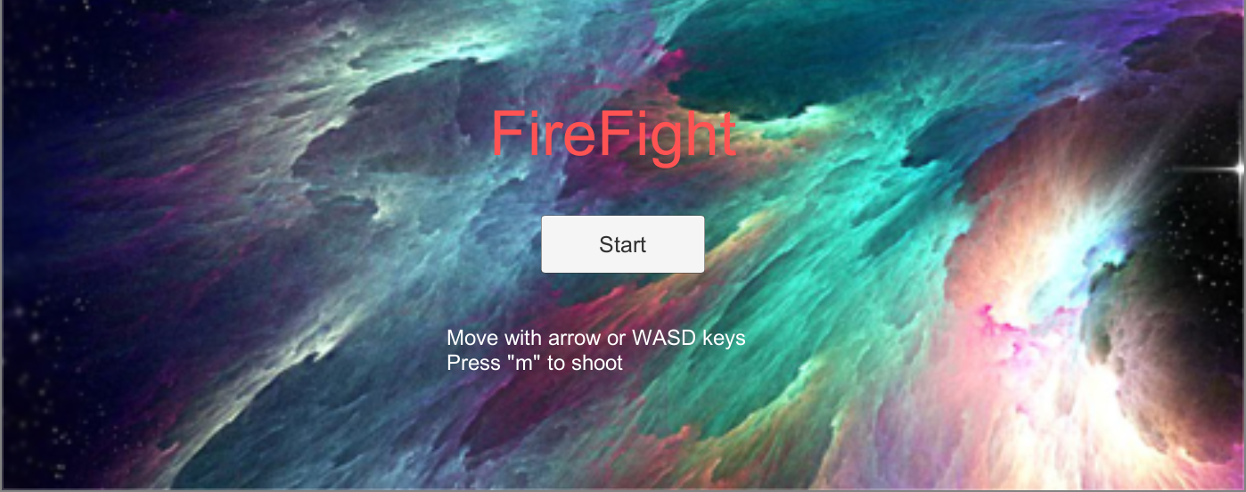

Start State^

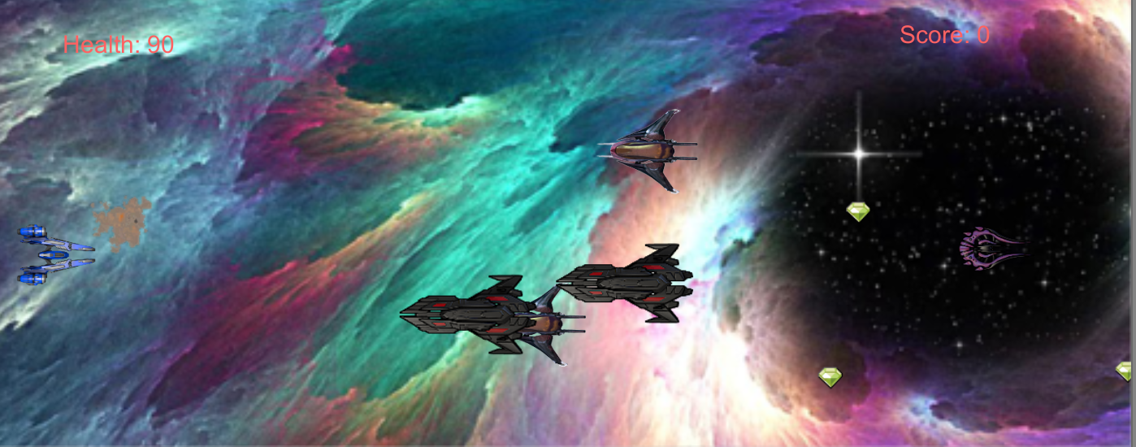

Gameplay State^

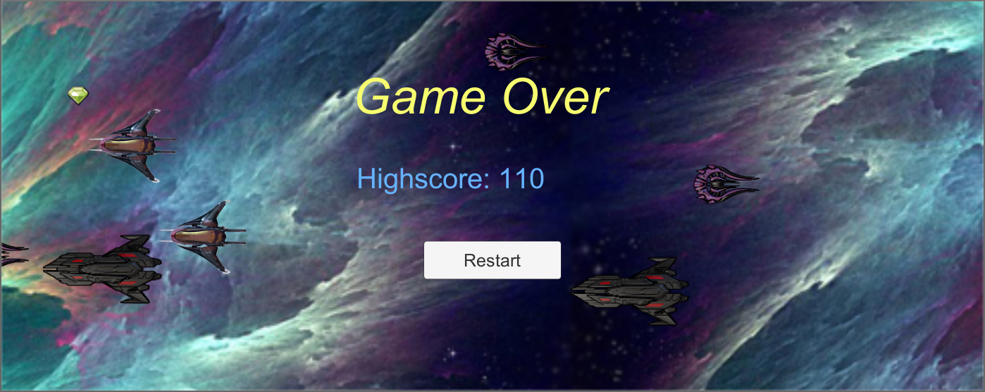

Game-End State^

# Enemies

There are 3 types of enemies. The two ships named alien and banshee are very similar. Both can be destroyed if they hit your ship. Banshee moves slightly faster than alien. The larger black ship moves at a slow pace, but cannot be destroyed. The player will need to avoid this ship to not take damage.

# Scoring

The player can get points by collecting the green gems that appear random in the game. Another way to score points is if the player shoots down an enemy. 5 points for shooting an enemy down, and 20 points for getting a gem because it is harder to get them.

# Sound Index

1. explosion.wav – explosion sound when ships explode

2. gemCollect.wav – sound plays when a gem has been collected

3. backgroundMusic.mp3 – background music

# Art/Multimedia Index

Background -http://wallpaperbackgrounds.com/Content/wallpapers/sci%20fi/space/152721-43879.jpg



Player Ship - http://1.bp.blogspot.com/-SqwrVIJoXXY/U9vXJm7TiiI/AAAAAAAABwU/DyQAiOXcIgU/s1600/blueships1.png

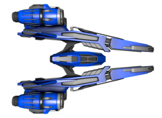

Enemy Ship (large ship) - http://3.bp.blogspot.com/-cg1jtrxaZ8Y/Ufl5SmFUVaI/AAAAAAAAAzY/KBxNVcMmOB0/s1600/F5S4.png

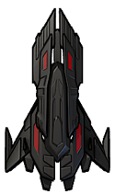

alien ship (small ship) - http://4.bp.blogspot.com/-tZK9_ykLRXM/UdSJOPJCcuI/AAAAAAAAAuY/rWqPKSpQ7rU/s238/alien3.png



banshee (small ship) - https://s-media-cache-ak0.pinimg.com/736x/97/f8/57/97f857ad509c10d41325a216bd86912b.jpg

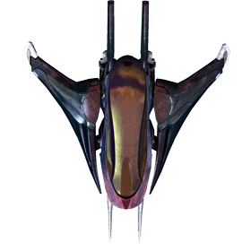

Gem - https://lh3.googleusercontent.com/7sAjp-SkQ9XAoh2VQTbIjOe7hO2D3gPiEKJIwnEPZEcM3hadAhY0Oy2Hfj4KH8UZoRj1-tuU=w211-h210-p-no



bullet - http://bbsimg.ngfiles.com/2/5769000/ngbbs42d4f33e2d9cb.gif

../Game%20images/bullet.png

# Notes

GitHub link - <https://github.com/NobleElemental/Unity-2D-game>

Upload speed is slow, which makes it hard to keep uploading new files for version control.